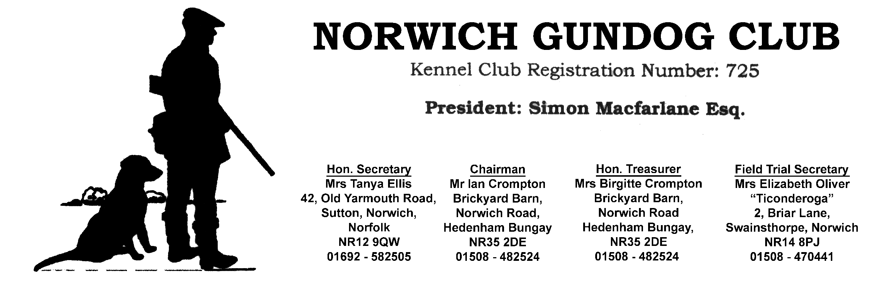
NORWICH GUNDOG CLUB
Kennel Club Registration Number: 725

President: Mr Robert Carter
AGM held on 23RD May 23
at Beaters Retreat, Ditchingham Estate

Those present: Birgitte Crompton (BC), Ian Crompton ( IC), Sarah Gadd (SG), Jules Hughes (JH), Alan Jennison (AJ), Stan Leathers (SL), Abigael Polley (AP) Anne Rayner (AR), Reg Rayner (RR), Mike Tallamy ( MT), David Wall (DW), Pam Wimmer (PW).

Apologies for Absence: Mark Allen, Steve Polley, Colin Walpole.

Approval of Minutes from AGM 13.6.22
Proposer: DW seconded by RR

Matters Arising: None

Chairmans Report:

The summer program was very well supported with the Novice/Puppy/ Young handler test at Thickthorn.
Our grateful thanks to our host Charles Watt. Thanks also to Graham Thompson and RR for setting up the tests.
We had a good field and it went very well.

RR organised two training days a Kilverstone which went very well. Thank you very much Reg.

We had our Open Cold Game test at Kirby Cane which was superb with a very high standard of dog work all day, good judging and a good team of guns and throwers kept the momentum all through. Big thank you to Mr Edward and Lady Hermione Crisp, our host, and Darren Wright for all of his help and time.

Field trials. Out of Covid and into bird flu. a great shame. We had two trials set at Leatheringsett and at Kelling with our very generous hosts which unfortunately had to be cancelled at short notice due to the risk of avian flu.

We were lucky to be able to hold one novice trial late in the season with the very generous invitation of Mr John Alexanda and Nick Meale. Which ran very well with a very worthy winner. I would also like to express thanks to Steve Polley for all of his help before the trial and on the day.
This trial invitation came at short notice and was done using FTMS. This needed to be set up at very short notice. Special thanks to BC, PW, JH and Tim Hankey for taking up the reigns and making it work.
IC thanked all of the people responsible for getting the web site set up and contacting all of the members by phone to ensure that news got to each and every one. That is thanks to JH, PW, BC and DW for getting the show on the road. Especially big thanks to JH for her professionalism in building a very smart website.

Thanks to Nick Clitheroe, AP, PW JH and BC for all of the work getting the trials and making the days work so well.
Not forgetting BC for the lunches and snacks at all of the events.

Let us hope for a bird flu free shooting season to come and that we can have a season to
enjoy.

Secretary’s report:

JH thanked PW for all her “hands on” help as part of their shared Secretary role. Website was launched March 23. FTMS made available from December 2022. All tests also available for online entries. Email and post remain for those not registered with FTMS.

Adoption of accounts year end Feb 2023 :

BC, as Treasurer presented the accounts. Club made a profit of £466.05.
The introduction of online communication will reduce the high cost of printing posting and stationery for the coming year.
Proposer : PW seconded AP

Election of Officers:

Mark Allen, Nick Clitheroe, Lee Moulton, AR & RR have decided not to stand. IC thanked all for their past help and commitment to the Club. Rest to stand.
New Committee members : SG, AJ and MT were voted in by a show of hands. The rest of the officers of the Club accepted to stand.
Replacement committee member – SL voted in , proposed by AJ, seconded by PW and welcomed by a show of hand.
No one showed an interest for the Vice Chairmans vacancy.

FT Award:

Two applications were received for the Field Trial Shield which was awarded to Sarah Gadd.

AOB:

IC expanded on the need for a Vice Chairman.

Lots of discussion regarding the best was forward with offering different types of Training days to increase interest.

It was suggested that the Trial winnings should be increased -the matter was discussed with the following proposed by AP and seconded by PW-:

Total Prize winnings to be equal to the entry Fee.
i.e entry fee £65
1st place £35, 2nd £20 3rd £10

AGM closed 9.06pm Minutes recorded by JH

